Q2.

import java.util.Scanner;

class A2{

public static void main(String args[]){

int A[][]=new int[3][3];

Scanner kb=new Scanner(System.in);

int r,c;

for(r=0;r<3;r++){//0 1 2

for(c=0;c<3;c++){// 0 1 2

System.out.println("Enter Element Index "+r+c+" : ");

A[r][c]=kb.nextInt();

}

}//input

System.out.println("Array Elements Are : ");

for(r=0;r<3;r++){

for(c=0;c<3;c++){

System.out.print("\t"+A[r][c]);

}

System.out.println("");

}//output

}

}

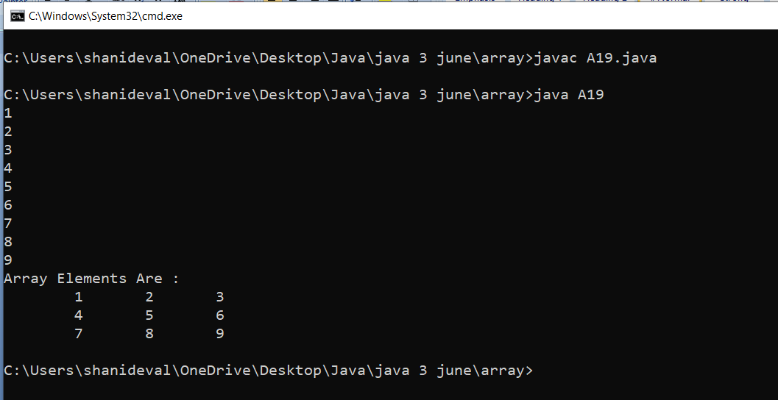

Q2.Write a java program to print sum of two matrix A

|  |  |  |
| --- | --- | --- |
| 10 | 20 | 30 |
| 40 | 40 | 60 |
| 70 | 80 | 90 |

B

|  |  |  |
| --- | --- | --- |
| 1 | 2 | 3 |
| 4 | 4 | 6 |
| 7 | 8 | 9 |

C

|  |  |  |
| --- | --- | --- |
| 11 | 22 | 33 |
| 44 | 55 | 66 |
| 77 | 88 | 99 |
|  |  |  |

import java.util.Scanner;

class A2{

public static void main(String args[]){

int A[][]=new int[3][3];

int B[][]=new int[3][3];

int C[][]=new int[3][3];

Scanner kb=new Scanner(System.in);

int r,c;

System.out.println("Enter Matrix A : ");

for(r=0;r<3;r++){//0 1 2

for(c=0;c<3;c++){// 0 1 2

System.out.println("Enter Element Index "+r+c+" : ");

A[r][c]=kb.nextInt();

}

}//input

System.out.println("Enter Matrix B : ");

for(r=0;r<3;r++){//0 1 2

for(c=0;c<3;c++){// 0 1 2

System.out.println("Enter Element Index "+r+c+" : ");

B[r][c]=kb.nextInt();

}

}//input

//matrix Addition

for(r=0;r<3;r++){

for(c=0;c<3;c++){

C[r][c]=A[r][c]+B[r][c];

}

}

System.out.println("output of MATRIX A : ");

for(r=0;r<3;r++){

for(c=0;c<3;c++){

System.out.print("\t"+A[r][c]);

}

System.out.println("");

}//output

System.out.println("output of MATRIX B : ");

for(r=0;r<3;r++){

for(c=0;c<3;c++){

System.out.print("\t"+B[r][c]);

}

System.out.println("");

}//output

System.out.println("output of MATRIX C Addition : ");

for(r=0;r<3;r++){

for(c=0;c<3;c++){

System.out.print("\t"+C[r][c]);

}

System.out.println("");

}//output

}

}

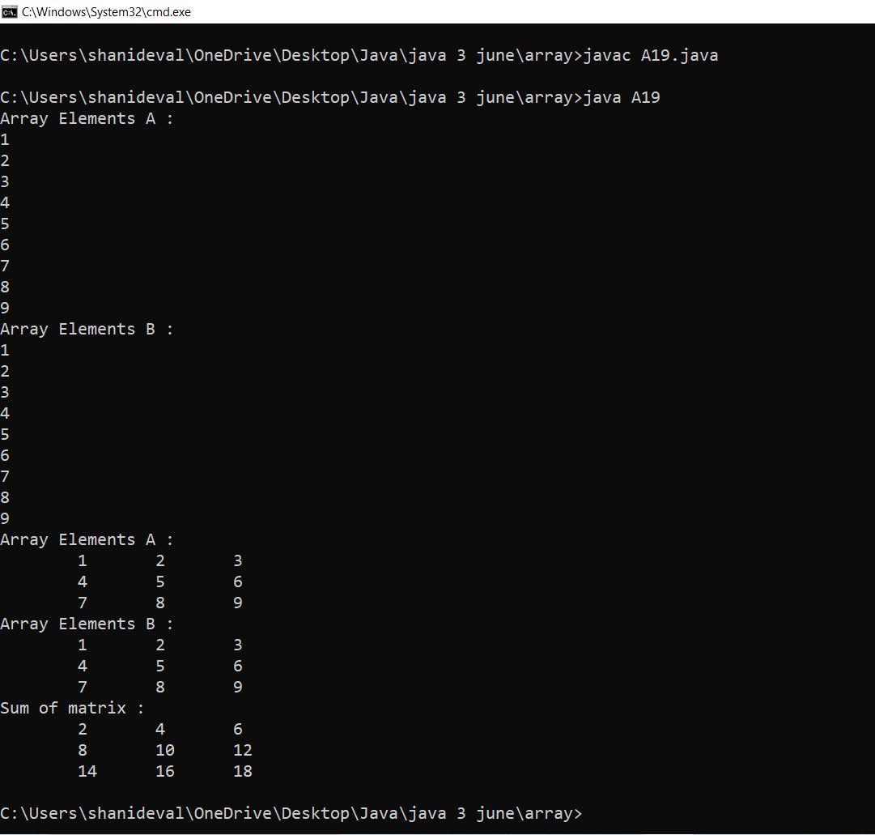

Home Work:

1. Write a java program to print multiplication of two matrix
2. Write a java program to print row wise sum and column wise of a particular matrix

A

|  |  |  |  |
| --- | --- | --- | --- |
| 10 | 20 | 30 | 60 |
| 40 | 50 | 60 | 150 |
| 70 | 80 | 90 | 240 |
| 120 | 150 | 180 |  |